[CprE 381] Computer Organization and Assembly-Level Programming, Fall 2017

Lab 3 Report

Lab Partners ___Larisa Andrews_____________________________

______________________________________________

______________________________________________

Section /Lab Time __Thursday 2-4 PM_______________________

Refer to the highlighted language in the lab 3 instruction for the context of the following questions.

- [Part A (a)] Note the number of cycles. Also, attach a screenshot of the terminal output from which you get the [# cycles]. (2 pts)

- # of cycles: 15722
- Screenshot: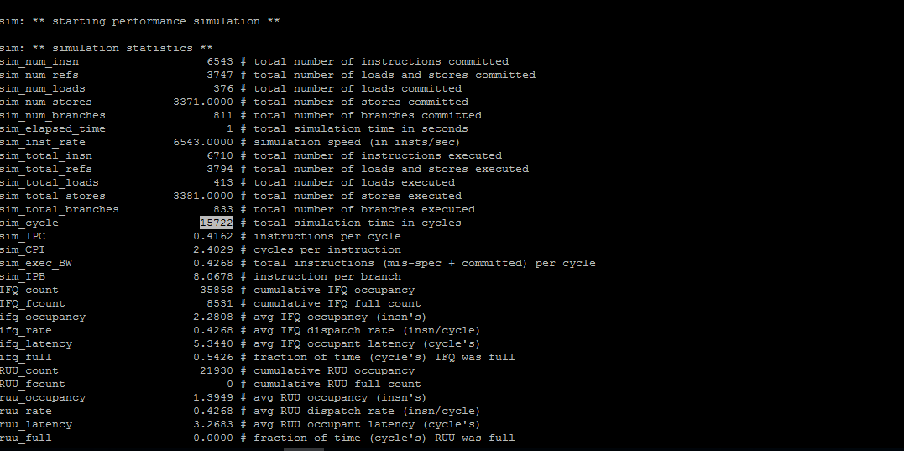

- [Part A (b)] Note the number of cycles. Attach a screenshot of the terminal output from which you get the [# cycles]. What is the number of cycles required for the division operations? (2 pts)
- # of cycles: 15633
- Screenshot: 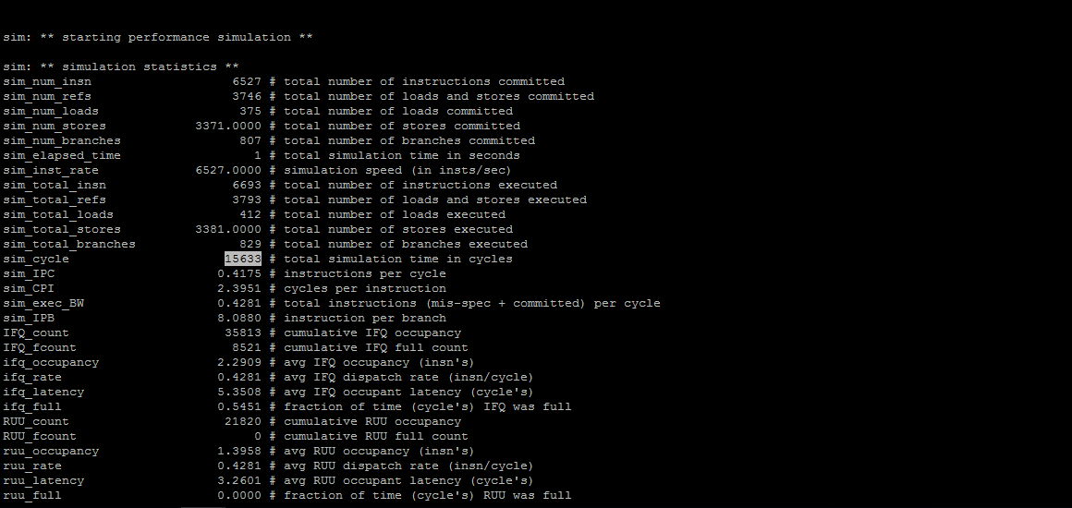
- # of cycles required for the division:
15722 – 15633 = 89/2 = 44.5 cycles

- [Part A (c)] Compare opt_division.c with unopt_division.c and report differences in the code. (2 pts)

- Differences: The opt uses shifting of bits and unopt uses divison.

- [Part A (d)] Using Amdahl’s Law and your results from (b), manually calculate the expected speedup going from unopt_division.c to opt_division.c assuming that the division operation achieved using shift operation brings down the cycle count to 1. Report your speedup. (2 pts)

- Speedup: 3000 clocl count – opt and unopt
- Unopt is going to take 3000 * 44.5 more clock cycles
- So SU = 133500/3000 = 44.5 cycles

- [Part A (e)] Run the precompiled binaries unopt_division and opt_division on sim-outorder and find any changes in cycles count and CPI of the programs. For each binary, attach a screenshot of the terminal output from which you get [# cycles] and [CPI]. Verify this with the manually calculated speedup. (2 pts)

- # cycles and CPI:
Binary (or program) | # cycles | CPI
unopt_divison | 118271 | 3.0060
opt_division | 42803 | 1.6752

- Screenshot:
- 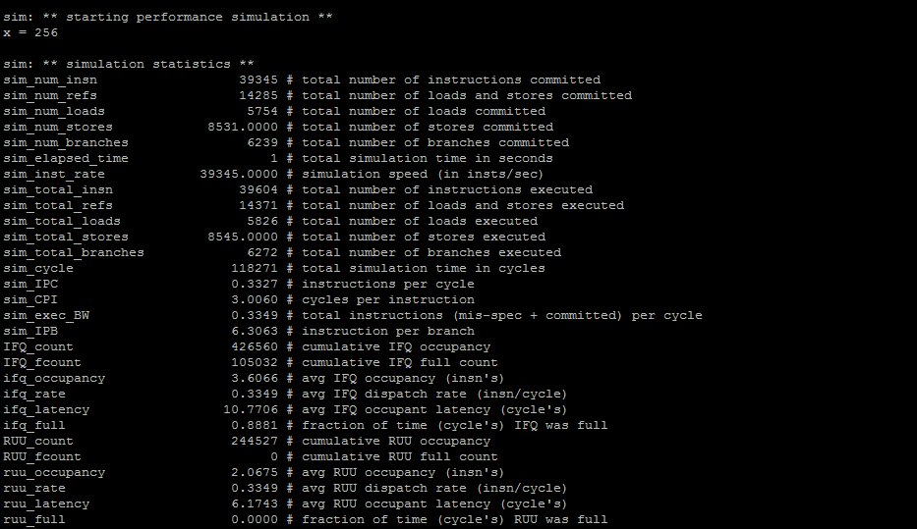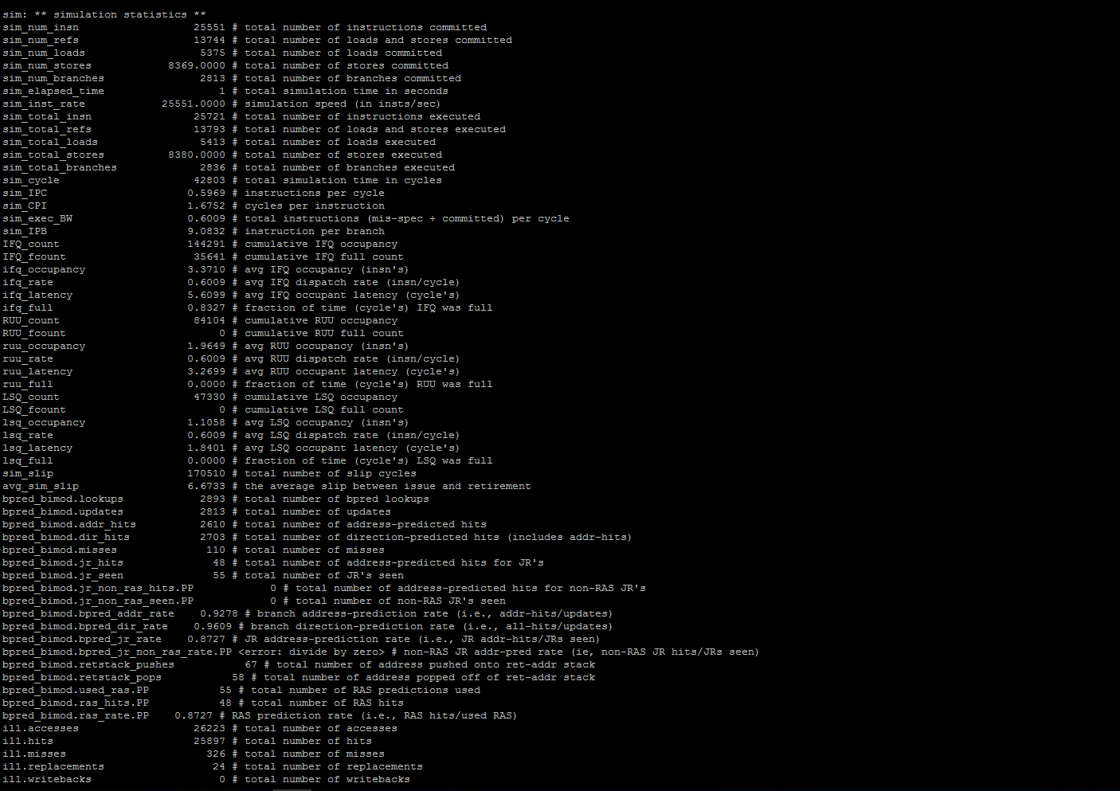
- Verify!
  - 118271/42803 = 2.763 cycles

- Identify and report differences between the optimized and un-optimized assemblies in terms of instructions. (2 pts)

- Differences: There are about 18 more instructions in the unopt code and there are no div commands in the opt code.
- Now run unopt_division binary on sim-profile using the –iprof flag. Do the same for opt_division binary provided to you in the zip file. Compare instruction mix (div vs sra). For each binary, attach a screenshot of the terminal output from which you get [# of instructions for div, sra, addu, and addiu]. (2 pts)

- # of instructions
Binary | div | sra | addu | addiu
unopt_division | 3000 | 12 | 4427 | 5571
opt_division | 0 | 3009 | 1202 | 2418

- Screenshot:
- 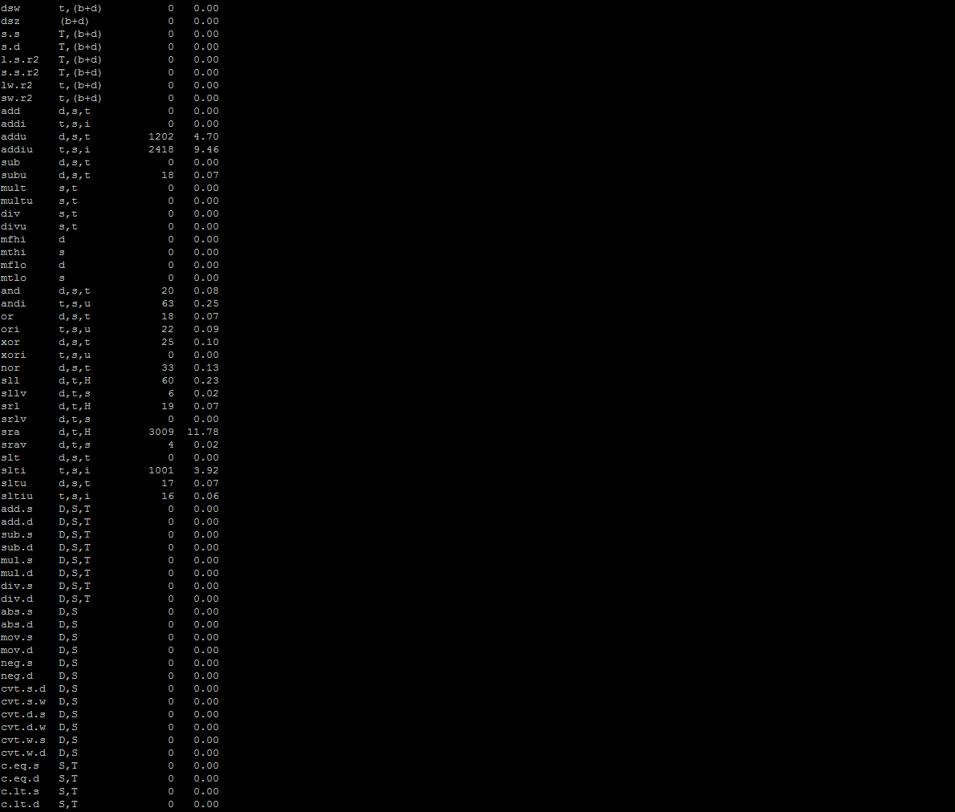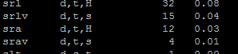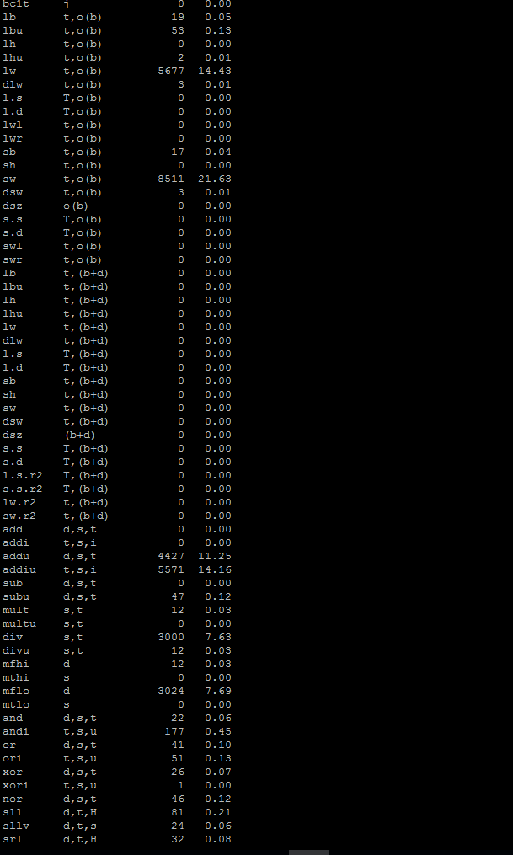

- Annotate the given opt_division.s assembly code (starting from main: to .end main), line-by-line, and explain which line in the opt_division.c code corresponds to which line(s) in the assembly code. (3 pts)

- Annotate
- Explain
Put the annotated code in the zip file.
- Repeat (h) for unopt_division.s and unopt_division.c. (3 pts)

- Annotate
- Explain
- Put the annotated code in the zip file.

